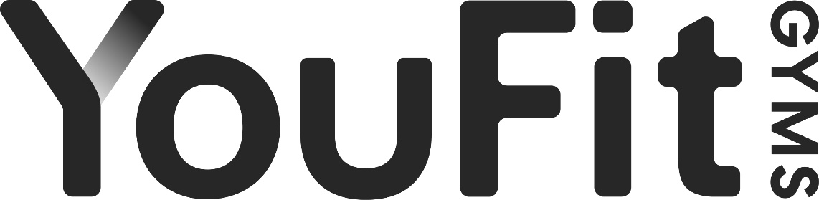
YOUFIT CLUB POLICY & GUIDELINES MEMBERSHIP POLICY FORM

I have been informed of the basic dress code, which includes:
- Clean workout clothing is required. Management will address any unsatisfactory hygiene and corrective action may be required.
- Appropriate athletic shoes only. No sandals, street shoes, flip-flops, or work boots are allowed in work out areas.
- Belt buckles, loose jewelry items, jeans, overalls, and work pants are not allowed in workout areas.
- All other clothing and shoes must be kept in lockers. Please keep all valuable items at home.

Use of facility is at my own risk:
- If I do not know how to use any equipment or fitness program, I will ask for assistance.
- Keep hands and feet away from all moving parts and weight stacks.
- Do not attempt to repair or adjust any equipment that has malfunctioned and report any equipment problem to the staff.
- Always use a spotter.
- Collars and clips must be used when using free weights.
- YouFit shall not be liable for any injury or damages resulting from my use of the services and/or facilities.
- If I become aware of any personal health problem, I will see a doctor before using the facility.
- A parent must accompany children under the age of 16. No one under the age of 13 is permitted inside our facilities.

I understand that the use of proper gym etiquette is required during my workouts:
- Bringing a towel to the gym & wiping off or disinfecting equipment after use.
- Be courteous, at all times, to other members and staff.
- Allow others to work in during your rest period.
- Dropping or slamming weights is not acceptable.
- Members are not allowed to bring in their own workout apparatus.
- Lockers are for day use only. Locks left overnight will be cut.
- Do not consume any food items, shakes, and supplement drinks in the workout areas of the club.
- Phone use is only permitted in the lobby.
- Re-rack all weights after use.
- Unless you are a law enforcement officer, you are not permitted to bring a firearm or weapon into our facilities.
- Express Circuit equipment is to be used by individuals completing the entire Express Circuit Workout only.
- Use equipment only as designed.
- Guests are only permitted with Premium or Premium+ members or if a day pass is provided or purchased. Valid ID must be presented and all YouFit policies must be followed.
- A delinquent membership account will result in denied access to all YouFit facilities until corrected.

I understand that YouFit is not responsible for loss or theft of personal property:
- Loss in the club or parking lot is not the responsibility of YouFit and I will not hold them liable.
- I have been informed that it is best not to leave valuables in my vehicle or bring them into the club.
- YouFit is not responsible for any lost, damaged, or stolen items.

I understand that YouFit is not liable for services or Agreements offered by independent contractors & outside companies.
- I acknowledge that the responsibility for fulfillment of services is of no responsibility to YouFit.
- Any disputes regarding payments or performance for services should not be directed to YouFit.
- Outside trainers are not permitted unless approved by management.
By joining I hereby certify that I have read and understand the above policies.
These policies must be followed at all times. Violation may result in immediate termination of your membership.

6438 MASTER FL NC ADDED 7794

